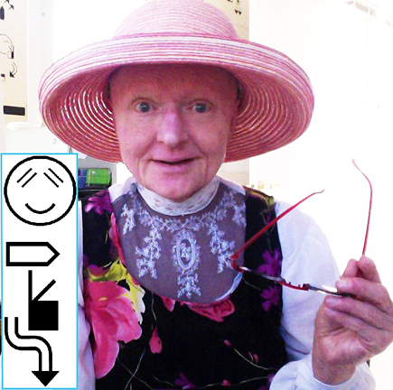
Valerie Sutton
Inventor, Sutton Movement Writing

SignWriting was first invented by Valerie Sutton in Denmark in 1974. It is one of five sections of Sutton Movement Writing, a system for reading and writing body movement. Sutton grew up in professional ballet training in Southern California, and first invented DanceWriting, preserving the historic Bournonville Schools, a ballet system used by the Royal Danish Ballet. In 1974, while teaching the Royal Danish Ballet to read and write dance, a researcher at the University of Copenhagen, Dr. Lars von der Lieth, asked her to develop a way to write the gestures of hearing person’s compared to the movements of Danish Sign Language for a research project. This was the beginning of SignWriting.
Establishing a US non-profit educational organization, the Center for Sutton Movement Writing, in Southern California in 1974, Sutton returned to her home in California to continue to work full time with SignWriting, establishing a series of research projects. The first was the SignWriter Newspaper published from 1981-1984, working with Founding Editor Nancy Fray Romero, and hiring skilled signers to write articles in written American and Danish Sign Languages. It was a 20-page newspaper distributed to schools and researchers. In 1982, Valerie was invited to return to Denmark to present to teachers of Deaf children in the Danish School System, and after training Danish teachers in SignWriting, the system was used in Deaf Education in Denmark from 1982-1988.
In 1988, in La Jolla, California, Valerie worked with Lucinda O'Grady to establish the Deaf Action Committee for SignWriting (the DAC). Deaf researchers met weekly in Valerie’s home to write the first ASL dictionary in SignWriting. From 1986-1996, Valerie worked with software developer Richard Gleaves, to develop the SignWriter Computer Program, a sign language processor for the Apple //e, //c and MS-DOS. In the 1990’s Valerie collaborated with ASL storyteller and teacher Darline Clark Gunsauls, to develop written literature in ASL, resulting in the “SignWriting Children’s Stories Series in ASL”.
Valerie is the designer and webmaster of nine web sites, including SignWriting.org, DanceWriting.org, SignBank.org, & MovementWriting.org. The first posting of SignWriting.org was on September 20, 1996, posting free SignWriting lessons and software online. In 1995 she established and still hosts the SignWriting List, informing list members about new developments. The SignWriting List became a vibrant list still online after 20 years, now hosted at Valencia College in Florida, with over 200 members from 20 countries, discussing sign language research, education, literature and software.
In 2004 Steve Slevinski started SignPuddle software, collaborating with Valerie Sutton and the Center for Sutton Movement Writing. SignPuddle Online, at SignBank.org and SignPuddle.org, is used worldwide by signers to write their sign language literature and dictionaries in the SignWriting Script, currently using the International SignWriting Alphabet 2010, which Steve Slevinski has established on the internet as TrueType Fonts that can be used in all web browsers, and on iPhones, iPads and other Apple devices. The SignWriting Script will officially be available in Unicode version 8 in mid-2015, and was also officially recognized as a world script by the International Organization for Standardization (the ISO) as Script ISO-15924, Sgnw, 095, on October 10, 2006.
Valerie’s collaboration with Deaf native signer Adam Frost, interpreter Nancy Fray Romero, software developer Steve Slevinski and other remarkable contributors from the Wiki software world is leading to future Wikipedias in written sign languages using the SignWriting Script. The ASL Wikipedia is already up and running on two test web sites:
http://ase.wikipedia.wmflabs.org/wiki/Main_Page and http://incubator.wikimedia.org/wiki/Special:PrefixIndex/Wp/ase/
The SignWriting Symposium 2014 celebrated 40 years of writing sign languages with 40 presentations from 12 countries including 42 presenters, streamed live on Google Hangouts and YouTube. It is an excellent example of the numerous projects using the SignWriting Script around the world. SignWriting is used by thousands of people in over 40 countries: SignWriting Symposium 2014: www.signwriting.org/symposium/2014.
For more information on the history of SignWriting: SignWriting.org/library/history

